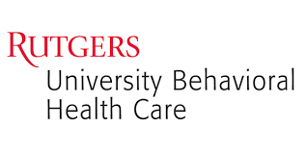

**Behavioral Research & Training Institute**

**Technical Assistance Center**

**Thursday, June 9, 2022**

**9:30am – 12:45pm**



**Behavioral Health & Criminal Justice Virtual Conference**

*Doing Treatment, Not Just Time*

***Screening, assessment, and treatment planning for behavioral health consumers across criminal justice settings.***

**Click here to Register**

**(This event is FREE)**

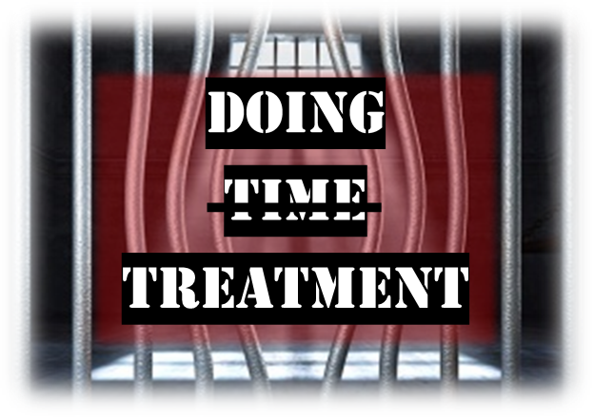

**Featured Speaker:**

**Roger H. Peters, Ph.D.**

Department of Mental Health Law and Policy

Louis de la Parte Florida Mental Health Institute

College of Behavioral and Community Sciences

University of South Florida

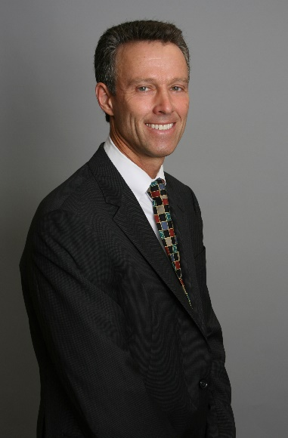

**Free**

**Continuing Education**

**Credits Provided!!!**

***We gratefully acknowledge the sponsorship of this event by the New Jersey Division of Mental Health & Addiction Services***

**For additional information, please contact Tameka Chatman at**

[**tameka.chatman@rutgers.edu**](mailto:tameka.chatman@rutgers.edu)

**Meet the Presenter:**

**Dr. Roger Peters** is an Emeritus Professor in the Department of Mental Health Law and Policy at the University of South Florida, and holds a joint appointment in USF’s College of Public Health. He currently serves as a consultant to the U.S. Department of State, Bureau of International Narcotics and Law Enforcement Affairs (INL) and the Colombo Plan (Sri Lanka), and as a consultant to the Organization of American States (OAS), Inter-American Drug Abuse Commission (CICAD). During his 35 years on the faculty of the University of South Florida, he served as Department Chair from 2004-2011, and as Associate Chair from 2002-2004. Dr. Peters received his Ph.D. in clinical psychology from the Florida State University, following completion of a pre-doctoral internship at the University of North Carolina, School of Medicine. He is a licensed Psychologist in Florida. Dr. Peters serves as Vice President of the International Consortium of Universities for Drug Demand Reduction (ICUDDR). He also serves on the Florida Supreme Court’s Steering Committee on Problem-Solving Courts, and has been a faculty member of the National Judicial College since 2014. He has served as a consultant to the United Nations Office on Drugs and Crime (UNODC) and the World Health Organization (WHO) in developing guidelines on “Treatment Alternatives to Conviction or Punishment”, and is a member of the Treatment Expert Advisory Group (TEAG) for the Colombo Plan. Dr. Peters is on the editorial boards for the Psychiatric Rehabilitation Journal, Drug Court Review, the Journal of Dual Diagnosis, Addictology, and the Journal for Advancing Justice. Dr. Peters served as Chair and Co-Editor of the SAMHSA/CSAT Treatment Improvement Protocol (TIP) #44 on “Substance Abuse Treatment for Adults in the Criminal Justice System”.

Agenda

|  |  |  |
| --- | --- | --- |
|  | **Thursday, June 9, 2022** |  |
| 9:00 AM—9:30 AM | Check-In |  |
| 9:30 AM—11:00 AM | Effective screening, assessment, and treatment planning for behavioral health consumers with criminal justice involvement. | Roger Peters, Ph.D. |
| 11:00 AM—11:15 AM | Break |  |
| 11:15 AM—12:45 PM | Exploring alternatives to incarceration for behavioral health consumers. | Roger Peters, Ph.D. |
|  | – Thank you for attending! |  |

**Program Goal:** To increase the use of evidence-based and promising practices when conducting screening, assessment and treatment planning for justice-involved behavioral health consumers, as well as highlight effective alternatives to incarceration.

**Objectives**:

•Describe at least 2 effective practices/policies regarding screening and assessment of behavioral health consumers across criminal justice settings.

•Describe at least 2 effective practices/policies treatment planning with behavioral health consumers across criminal justice settings.

•Examine 3 or more policies, trends, models, and/or barriers pertaining to alternatives to incarceration for behavioral health consumers.

**Target Audience:** Professional Counselors, Alcohol & Drug Counselors, Social Workers, Psychologists, Marriage & Family Therapists, Psychologists, Physicians, Nurses, Certified Recovery Support Practitioners, National Board Certified Counselors, Persons in Recovery, and Criminal Justice System professionals.

**FREE Professional Contact Hours Provided!!!**

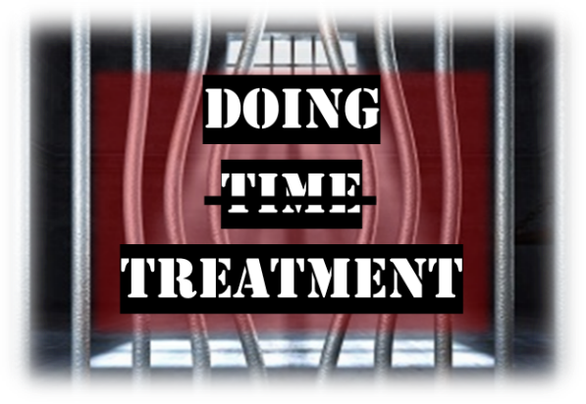**FREE Professional Contact Hours Provided**

*Please note that participants may not be eligible for continuing education credits if they are not on time*

*and present for the entire event. Partial credits will not be issued to participants arriving late, leaving*

*early, or those who do not return after the scheduled break.*

* Professional Counselors:

***Screening, assessment, and treatment planning for behavioral health consumers across criminal justice settings***

* Marriage and Family Therapists:
* Licensed Clinical/Certified Alcohol and Drug Counselors:
* Social Workers:
* Psychologists:
* Physicians:
* Nurses:
* Certified Recovery Support Practitioner:

**Additional Information**

* **Cancellation Policy:** If you have registered but cannot attend this program, please call so that we can offer your place to an individual on the waiting list. In case of inclement weather or other unforeseen circumstances, please call 732-235-9290 beginning at 8 a.m. on the scheduled conference date for a recorded informational message about the status of the event.
* **Special Needs:** If you have a special needs (ADA) and wish to discuss possible provisions, please contact Technical Assistance Center at 732-235-9290.
* **Delivery Format:** Live Virtual Training Program

**Registering for an activity in RBHS CloudCME.**

1. Login: Click on registration link. You will be prompted to create an account if you are first time user. Please fill out all fields to complete profile and return to original link to complete registration. Rutgers employees and affiliates should use their single sign on account information.
2. Register: Click on ‘REGISTER’ – Your name and email will appear in red with the message ‘If this is correct, click Continue to start your registration. If this is not you, please click 'Sign Out' in the site navigation above and login with your own account. Your name and email will appear in red font, indicating that you are logged in.
3. Message offering promotion code can only be used if you have been provided a code. *This message appears to all attendees even if there is no code. This does not stop the registration process. Click on Blue CONTINUE button.
4. Select registration type. Typically, there is only one option. (Ex: General Attendance; CE Certificate and Registration)
5. Survey: Select source of program registration information in checkbox.
6. To ensure payment and registration were completed please log into your RBHS CloudCME profile, select “MY CE’ Menu – go to registrations and receipts to confirm registration and payment completion.

